INTERNSHIP REPORT
Manufacturing Production & Quality Analytics Dashboard
LOHIA CORP LIMITED
By
Garima Darolia
Student of
Bachelor of Technology, Computer Science & Engineering
Dr. Ambedkar Institute of Technology for Handicapped, UP (Affiliated to Dr. A.P.J. Abdul Kalam Technical University, Lucknow)
Mentor: Sanjay Sir
2026

CONTENTS
1. Acknowledgement 3
2. Executive Summary 3
3. About the Company 3
4. Project Work and Description 5
5. Excel Report and Analysis 7
6. Power BI Report 8
7. Technical Details of the Power BI Project 10
8. Key Insights 11
9. Challenges Faced During the Internship 11
10. Skills and Professional Takeaways 12
11. Future Scope and Recommendations 12
12. Glossary of Terms 12
13. Conclusion 13

1. Acknowledgement
I would like to express my sincere gratitude to Lohia Corp Limited for giving me the opportunity to intern with the organization. I am especially thankful to Sanjay Sir, my internship mentor, for his continuous guidance and for shaping the direction of this project from the start.
This internship has been a great learning experience, and I am grateful to everyone at Lohia Corp who supported me along the way.
Garima

2. Executive Summary
This report is submitted by Garima, a final-year B.Tech Computer Science & Engineering student at Dr. Ambedkar Institute of Technology for Handicapped, UP, affiliated to AKTU, for a summer internship completed at Lohia Corp Limited, Kanpur.
I independently designed and built the Manufacturing Production & Quality Analytics Dashboard — a three-page Power BI solution, backed by a companion Excel/Power Pivot workbook — that gives Lohia Corp's plant managers and quality teams a single, drill-down view of production, quality, and machine performance across the Kanpur and Bengaluru plants. The dashboard tracks target achievement, order delays, defect rates, and downtime through a set of DAX measures I authored, and has already surfaced an actionable finding: roughly 9.77% of orders are delayed, concentrated in specific machine categories rather than spread evenly — a pattern that was not previously visible through manual reporting.
The work was reviewed in depth by my mentor, whose feedback on my DAX logic and dashboard design sharpened the final product. This internship strengthened my ability to take a business problem, structure the right data model, and deliver a decision-ready analytics product end to end, and it has reinforced my intent to build a career in data analytics.

3. About the Company

3.1 Overview
Lohia Corp Limited is the flagship company of the Lohia Group and a Kanpur-based global supplier of machinery for the plastic woven fabric industry — covering circular looms, tape extrusion, tape winding, lamination, printing, multifilament spinning, and recycling equipment used to manufacture flexible packaging such as woven sacks, FIBC/jumbo bags, tarpaulins, geo-textiles, and agro-textiles. The company positions itself as a full-solutions provider, supplying not just individual machines but complete production lines that take raw polypropylene or polyethylene resin through extrusion, weaving, printing, and finishing to produce a finished woven fabric product.
Within this internship, I engaged primarily with the Manufacturing and quality functions that generate the production and machine-performance data this dashboard analyzes, giving me a working view of how a heavy-machinery manufacturer tracks its own shop-floor performance.

3.2 History
The company was originally incorporated in 1981 as Lohia Starlinger Limited, a joint venture between the Lohia family and Starlinger & Co. GmbH of Austria, set up to manufacture circular looms. Over the following decades it built in-house R&D and manufacturing capability, including a technology partnership with Windmöller & Hölscher that strengthened its technical base. In March 2013, following Starlinger's exit as a shareholder, the company was renamed Lohia Corp Limited, marking its transition to full independence and a distinct corporate identity in the global machinery market.
The Lohia Group itself traces back further, with the founding family diversifying from traditional trading businesses into high-tech machine manufacturing in the mid-1970s under Mr. Raj Kumar Lohia. What began as a single manufacturing venture has since grown into a diversified engineering group headquartered in Kanpur, spanning machinery, technical textiles, engineering plastics, and — more recently — new business lines such as personal protective equipment and mobility.
Across four decades of operation, the company has continued to add machine categories to its portfolio — moving from its original focus on circular looms into tape extrusion, winding, lamination, and recycling equipment — largely in response to the packaging industry's shift toward higher throughput, better fabric quality, and increasingly, sustainable and recycled material processing.

3.3 Global Presence & Scale
Lohia Corp has supplied machinery to customers in over 90 countries, with its equipment used to produce packaging for cement, fertilizer, and food grains, along with FIBC/jumbo bags and ventilated bags. Its global footprint is supported by subsidiaries and associates in the USA, Brazil, Thailand, Indonesia, the Philippines, and the UAE, in addition to sales agents across major woven-sack-producing markets. This geographic spread means that machine performance and quality data — of the kind this dashboard analyzes — is not just a domestic operations concern but a factor in the company's export reliability and reputation across very different markets and climates.
The company has also grown through acquisition and partnership: it acquired Leesona, a US-based precision winding equipment maker with over 130 years of history, in 2019, and J.J. Jenkins Inc., a synthetic fibre and monofilament machinery manufacturer, through Leesona in 2024. It also operates OMGM Extrusiontechnik, a joint venture with Italy's OMGM S.A.S. for monofilament and strapping extrusion equipment. These acquisitions have broadened Lohia Corp's addressable market beyond woven sacks into technical textiles, specialty yarns, and monofilament applications used in medical and defence contexts.

3.4 Group Companies
- Lohia Corp Limited — flagship company; woven plastics and packaging machinery
- Lohia Global Solutions — components and accessories for raffia machinery
- Threads (India) Limited — industrial synthetic sewing thread
- Injectoplast Private Limited — engineering plastic components for the automobile sector
- Technical Training & Research Centre (TTRC) — training and research hub for the raffia industry

3.5 Product Portfolio and Manufacturing Capabilities
The machine categories covered by this internship's dashboard reflect Lohia Corp's actual product portfolio, and understanding what each category does was necessary groundwork before any dashboard design could begin:
- Circular Looms (including the Nova 10, Nova 82, LSL, CSN 4, FSN 4, and Venti models) — weave flat tapes of polypropylene or polyethylene into the woven fabric base used for sacks and bags. These machines are Lohia Corp's original and best-known product line.
- Tape Extrusion Lines — draw and stretch molten resin into the flat tapes that circular looms later weave; tape quality here directly affects downstream fabric strength and appearance.
- Lofil Multifilament Lines — produce continuous multifilament polypropylene yarn used in sewing thread, ropes, and technical textile applications.
- Lamination Lines — bond additional film or fabric layers onto woven fabric to improve moisture resistance and print quality, typically used for higher-value packaging.
- Conversion Lines — cut, fold, and stitch finished fabric into bags, sacks, and FIBCs ready for end use.
- Recycling Machines — reprocess plastic waste and production scrap back into usable raw material, supporting the company's sustainability commitments.
Each of these machine categories carries its own typical defect patterns, cycle times, and maintenance needs, which is why the dashboard's machine-category slicer and Key Influencers analysis were designed to let users compare performance within a category rather than across dissimilar machine types.

3.6 R&D and Sustainability
Lohia Corp maintains an in-house R&D function alongside its manufacturing facilities in Kanpur, and has stated a long-term goal of becoming the global leader in woven plastics machinery. The company has also highlighted sustainability initiatives, including solar power adoption and support for recycled-materials processing equipment, as part of its broader commitment to responsible manufacturing. The Recycling Machines category in the company's product line is a direct reflection of this priority, and was one of the machine categories included in this internship's production and quality analysis.

3.7 Departments
- Manufacturing — production, engineering, and quality control
- Sales & Marketing — customer support, market research, and sales strategy
- Research & Development — materials science, process engineering, product design
- Finance — accounting, treasury, and taxation
- Human Resources — recruitment, training, and compensation
- Information Technology — infrastructure, applications, and cross-department system support
The internship was carried out within the analytics function supporting manufacturing operations, working closely with production and quality data from the company's Kanpur and Bengaluru plants.

4. Project Work and Description

4.1 Project Title
Manufacturing Production & Quality Analytics Dashboard

4.2 Background and Problem Statement
Before this project, production and quality data at Lohia Corp's Kanpur and Bengaluru plants existed across separate spreadsheets and machine logs, each maintained by different shift supervisors and quality personnel. Answering a simple question — such as which machine category was driving the most order delays this month — required manually pulling numbers from multiple files, a process that was slow, error-prone, and difficult to repeat consistently. Plant managers had visibility into what had happened on a given day, but no easy way to see patterns across weeks, plants, or machine categories.
This gap was the starting point for the project: build a single analytical tool that plant managers and quality teams could open on their own, filter to the plant, machine, or date range they cared about, and get an answer immediately — without waiting on a manually compiled report.

4.3 Objective
To design and build an interactive Power BI dashboard, from raw data to finished product, that gives Lohia Corp's plant managers and quality teams a single source of truth for production targets, order delays, and machine-level quality and downtime — replacing manual, spreadsheet-based reporting with a tool they can query and drill into themselves.

4.4 Scope
- Structured a production and quality dataset covering Lohia Corp's core machine categories — Circular Looms (Nova 10, Nova 82, LSL, CSN 4, FSN 4, Venti), Tape Extrusion Lines, Lofil Multifilament Lines, Lamination Lines, Conversion Lines, and Recycling Machines — across the Kanpur and Bengaluru plants
- Built the data model and authored the DAX measures in Power BI Desktop from the ground up
- Designed interactive dashboards with slicers, drill-downs, and conditional formatting aimed at non-technical plant users
- Presented findings directly to supervisors and, separately, to fellow interns

4.5 Methodology
The project followed a structured, iterative approach rather than attempting to build the finished dashboard in one pass:
- Requirement gathering — discussed with my mentor what plant managers actually needed to see day-to-day, rather than what data happened to be easiest to pull
- Data structuring — organized machine, plant, order, and date information into a clean, related structure that Power BI could model efficiently
- Data cleaning — removed duplicate and inconsistent entries, standardized machine and plant naming, and handled missing values before any measures were built on top of the data
- Measure design — authored DAX measures one at a time, checking each against manually calculated values before adding it to a visual
- Visual design — built each dashboard page around a specific question a plant manager or quality lead would ask, rather than adding visuals for their own sake
- Review and iteration — presented working drafts to my mentor and second supervisor, and revised the data model and DAX logic based on their feedback

4.6 Timeline
The project was carried out over the course of the internship alongside other assigned work, structured roughly as follows:
- Weeks 1–2 — onboarding, understanding Lohia Corp's machine portfolio and plant operations, and gathering reporting requirements
- Weeks 3–4 — data structuring, cleaning, and building the initial Power BI data model
- Weeks 5–6 — designing and authoring the core DAX measures, and building the Main Dashboard page
- Weeks 7–8 — building the Quality & Machine Analysis page, and beginning the companion Excel workbook for OEE and MTTR analysis
- Final weeks — refining the dashboard based on supervisor feedback, resolving technical issues, building the Drill Through page, and preparing this report and an internal presentation

4.7 Deliverables
- A three-page interactive Power BI dashboard (Main Dashboard, Quality & Machine Analysis, Drill Through)
- A companion Excel workbook with Power Pivot/DAX-based OEE and MTTR analysis
- A documented set of DAX measures for target achievement, delay tracking, and quality/downtime monitoring
- A written project report summarizing methodology, design, and insights

4.8 Results & Impact
- Consolidated production and quality data from two plants into one interactive reporting layer, where plant managers previously had to cross-reference separate spreadsheets
- Replaced static manual reporting with drill-down analysis, cutting the time needed to investigate a delay or defect from a manual lookup to a few clicks
- Identified that approximately 9.77% of orders were delayed and concentrated in specific machine categories — a pattern invisible in the prior reporting format
- Gave plant managers a repeatable framework they can use to monitor target achievement and downtime going forward, without further input from me
- Received strong technical validation from a second, more senior reviewer on the DAX logic and dashboard design, beyond the sign-off of my direct mentor

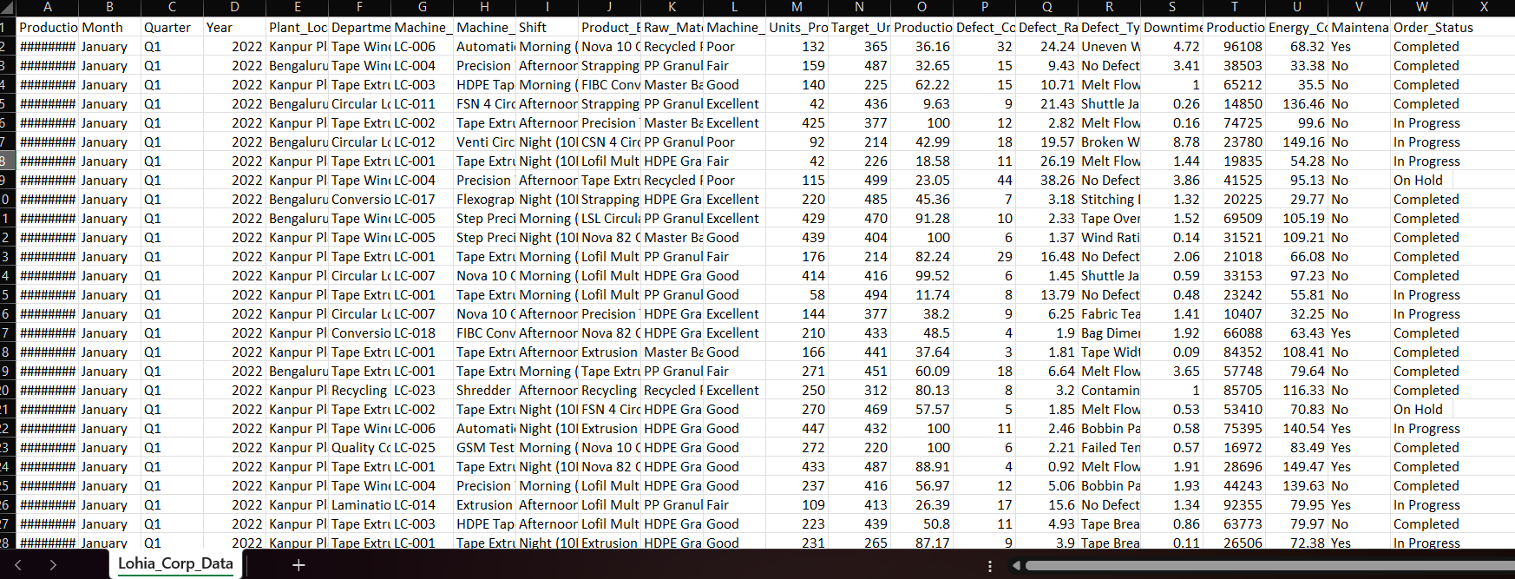
4.9(i) Dataset: Raw Data

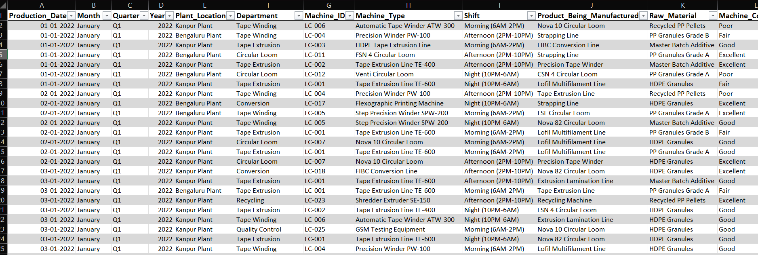
4.9(ii) Dataset: Tabular Data

5. Excel Report and Analysis
Alongside the Power BI dashboard, a companion Excel workbook was built to support deeper machine-reliability analysis — specifically Overall Equipment Effectiveness (OEE) and Mean Time Between Failures / Mean Time To Repair (MTBF/MTTR) — using Power Pivot and DAX within Excel.

5.1 Contents of the Excel Workbook
- Raw machine and production log data — machine ID, plant, date, run time, downtime hours, units produced, defect count, and maintenance events
- Power Pivot data model with DAX measures for OEE (Availability x Performance x Quality) and MTBF/MTTR
- Pivot tables summarizing downtime and maintenance frequency by machine and plant
- Supporting charts for OEE trend and maintenance frequency by machine category

5.2 OEE Calculation Methodology
Overall Equipment Effectiveness is calculated as the product of three components, each expressed as a percentage: Availability, Performance, and Quality.
OEE = Availability x Performance x Quality
Availability is Run Time divided by Planned Production Time, and captures how much scheduled time was actually used for production after subtracting downtime. Performance is (Ideal Cycle Time x Total Units Produced) divided by Run Time, and captures how close actual production speed came to the machine's rated speed. Quality is Good Units divided by Total Units Produced, and captures the proportion of output that met quality standards. Multiplying the three together gives a single OEE percentage that reflects availability, speed, and quality losses in one number — which is why it was chosen as the primary reliability metric for the Excel workbook.

5.3 MTTR Calculation Methodology
Mean Time To Repair (MTTR) were calculated to complement OEE with a more direct view of machine reliability and maintenance responsiveness.
MTTR = Total Downtime / Number of Failures
A lower MTTR indicates that when a breakdown does occur, it is resolved quickly. Tracking it — rather than downtime hours alone — made it possible to distinguish machines that fail often but are repaired quickly from machines that fail rarely but stay down for a long time when they do, which has different implications for maintenance planning.

5.4 Functions and Features Used
The workbook currently uses Pivot Tables and Power Pivot/DAX as its core analysis layer. This is actively being extended with additional Excel functions to make the sheet more self-contained and easier to audit without opening the data model.
Pivot Tables and Power Pivot/DAX are already implemented and form the backbone of the analysis — Pivot Tables summarize downtime, maintenance count, and production volume by machine and plant, while Power Pivot/DAX handles the OEE and MTTR calculations. Beyond this, XLOOKUP and VLOOKUP are being added to pull machine category and plant name into the main sheet from a master machine list, IF is being used to flag machines as high-downtime or on-target against threshold values, SUMIFS and AVERAGEIFS are being introduced to cross-check pivot table totals through direct formula-based aggregation, and conditional formatting is being applied to highlight OEE and defect rate values that fall outside acceptable ranges.

5.5 Technical Challenges
- Resolved a corrupted pivot cache that was causing incorrect refresh behaviour in the summary tables
- Identified and removed ghost columns left behind by earlier data imports, which were inflating row counts in the Power Pivot model
- Validated MTTR DAX formulas against manually calculated sample values before relying on them for the full dataset

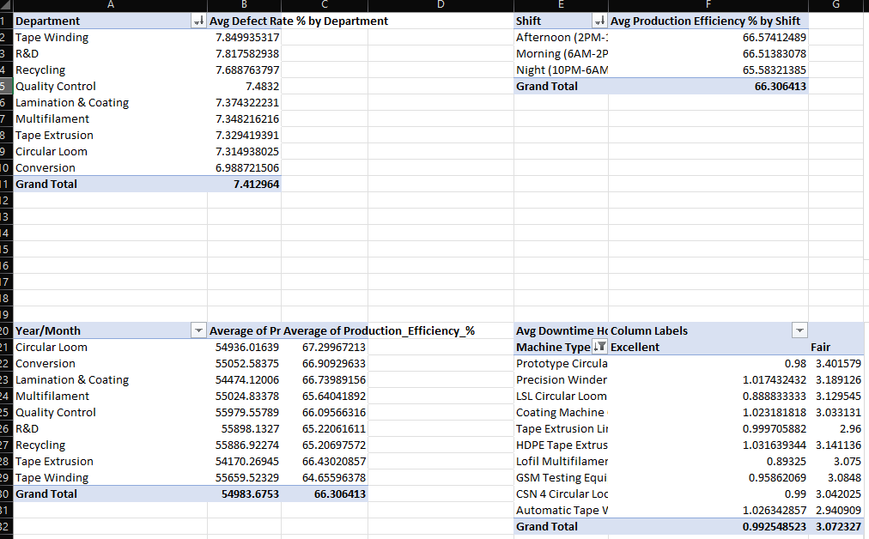
5.6 Pivot Tables

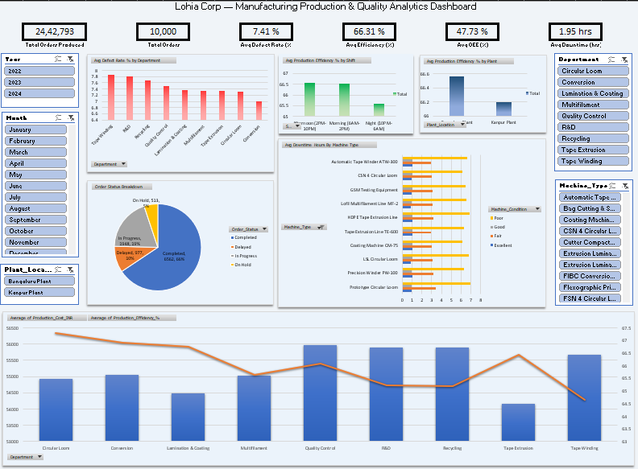
5.7 Excel Dashboard

5.8 MTTR Graph
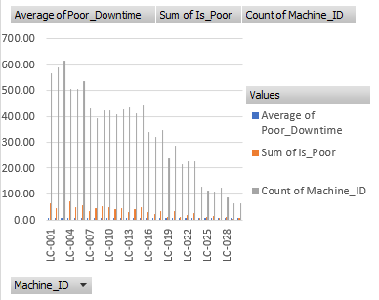

6. Power BI Report
The dashboard is built around a structured dataset of 10,000 production and quality records, modeled on Lohia Corp's actual machine portfolio and plant structure. It is organized into three pages, each supporting a different level of analysis, moving from a plant-wide overview down to individual order and machine detail.

6.1 Data Model
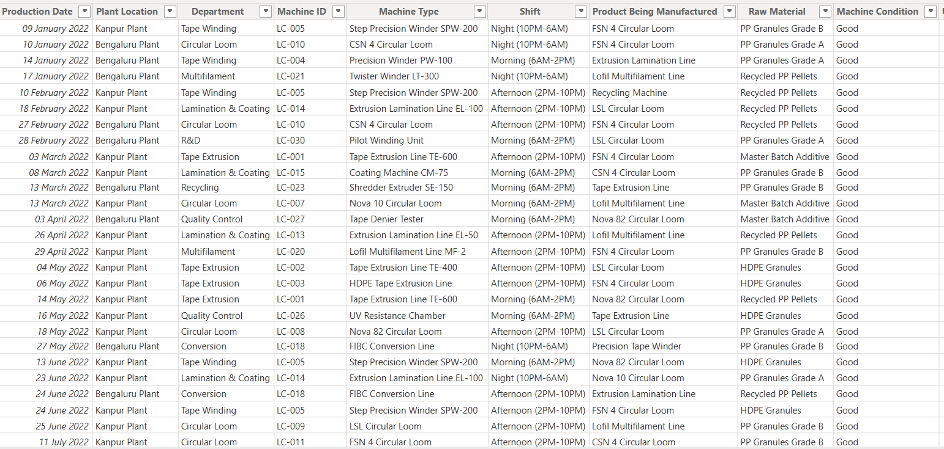
The underlying data model follows a star-schema pattern, with a central production/order fact table connected to dimension tables for machine, plant, and date. This structure was chosen over a single flat table because it keeps the dataset easier to maintain, lets DAX measures filter cleanly by any dimension, and mirrors how Power BI is designed to perform best at scale. Each machine record is tagged with its category (Circular Loom, Tape Extrusion Line, Lofil Multifilament Line, Lamination Line, Conversion Line, or Recycling Machine) and its plant (Kanpur or Bengaluru), so that every visual on every page can be sliced by either dimension without additional modeling work.

6.2 Page 1 — Main Dashboard
A plant-wide overview intended as the landing page for leadership. It answers the question a plant manager asks first thing in the morning: 'how are we doing right now, overall?'
- Five KPI cards summarizing Target Achievement %, Delayed Orders %, Avg Defect Rate, Avg Production Efficiency, and Avg Downtime Hours at a glance
- A gauge chart showing overall target achievement against a defined goal, so a manager can see in one glance whether the plant is ahead or behind
- A scatter plot correlating production efficiency against defect rate, to visually surface the quality-throughput trade-off across machines
- A treemap showing production volume distribution across machine categories, highlighting which categories are carrying the most production load
- An area chart and forecast line chart for production trend over time, giving a sense of trajectory rather than just a single snapshot
- Five interactive slicers (plant, machine category, machine, date range, order status) that cross-filter every visual on each page

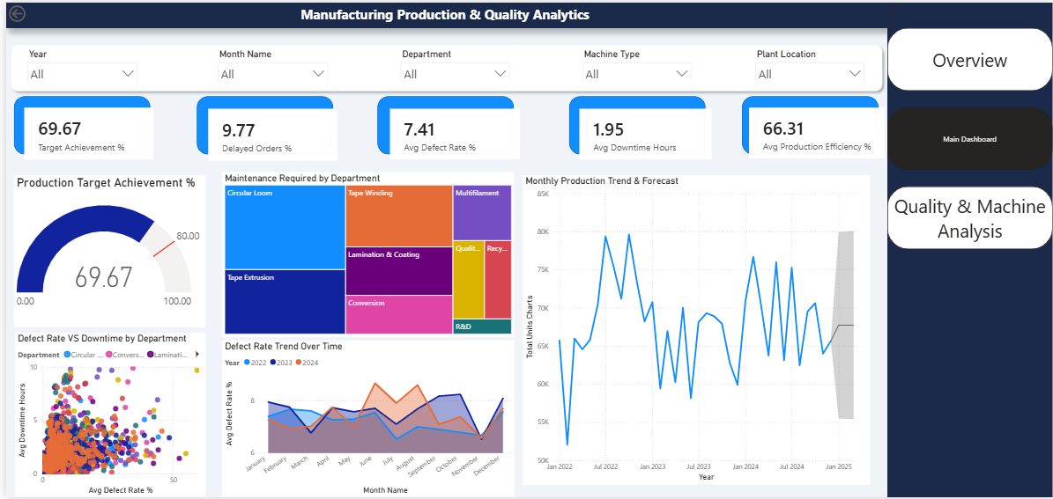

6.3 Page 2 — Quality & Machine Analysis
A diagnostic view built for quality teams and machine-line supervisors, focused on the follow-up question: 'given that something is wrong, where exactly, and why?'
- A Key Influencers visual that statistically ranks which factors (machine category, plant, shift, etc.) most strongly predict a high defect rate
- A Decomposition Tree that lets a user manually drill down through dimensions — for instance plant, then machine category, then individual machine — to trace a delay or defect back to its source
- A ribbon chart comparing machine category rankings over time, showing whether the same categories consistently underperform or whether the ranking shifts month to month
- A clustered bar chart comparing machine performance against an 80% target reference line, making underperforming machines visually obvious
- A matrix with conditional formatting that highlights machines or plants whose defect rate or downtime falls outside an acceptable range, without requiring the user to read every number
- A 100% stacked bar chart showing the composition of order outcomes (on-time vs. delayed) by machine category, to compare proportions fairly even where categories have very different order volume

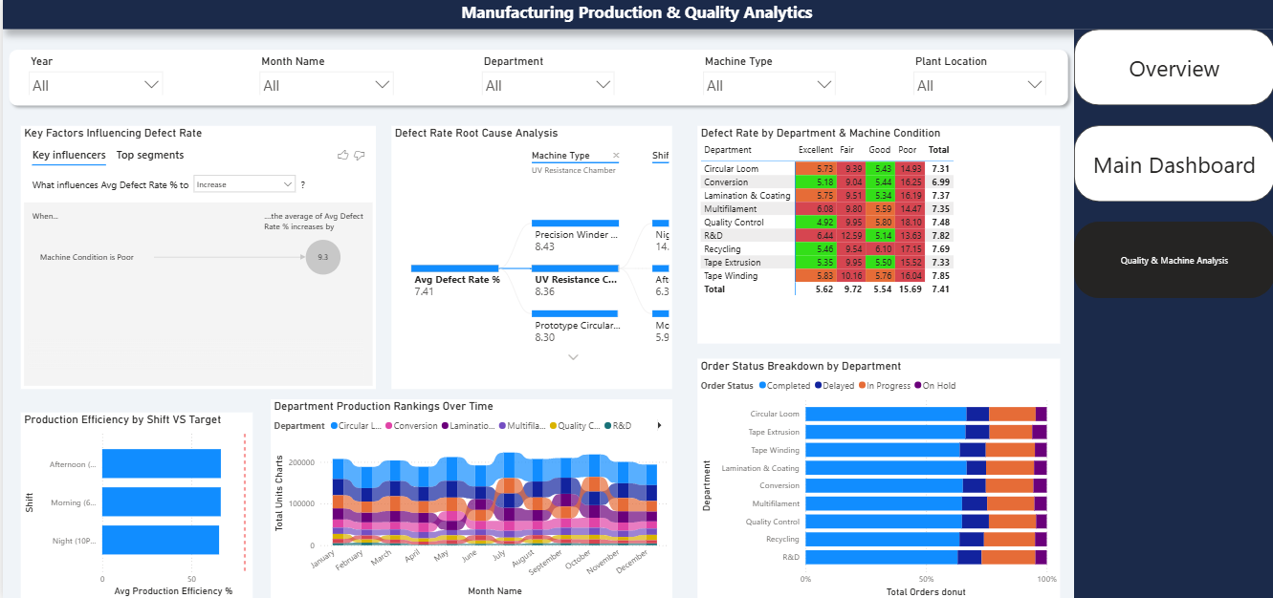

6.4 Page 3 — Drill Through Page
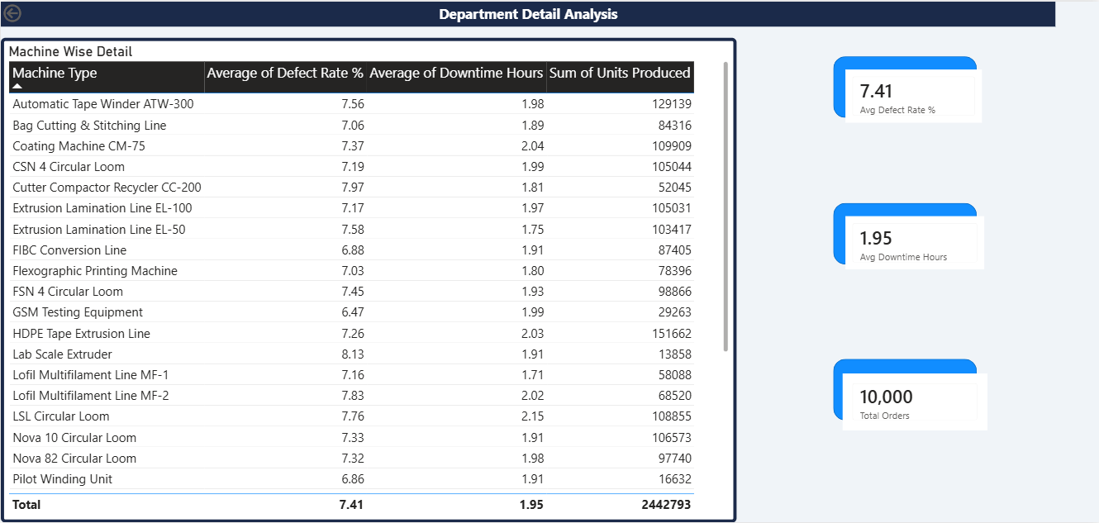
Designed to answer the most granular question: 'show me exactly what happened on this one order, on this one machine.' A user will be able to right-click any machine or order on Pages 1–2 and drill through to a detailed, order-level view showing individual production runs, defect logs, and maintenance history. This page, along with a consolidated Overview page, is in its final stages of development at the time of this report.

7. Technical Details of the Power BI Project

7.1 Tools & Technologies Used
- Power BI Desktop — data modeling and report creation
- Power Query — data cleaning and transformation
- DAX (Data Analysis Expressions) — calculated measures and KPIs

7.2 Data Model Design
- Star-schema relationships across machine, plant, order, and date dimensions
- Relationships built on machine ID, plant ID, and order date keys
- Date hierarchies enabled for time-based trend and forecast visuals

7.3 Data Cleaning and Power Query Steps
Before any measures or visuals were built, the raw production and quality data was cleaned and shaped in Power Query. This step is easy to underestimate but directly determines whether downstream DAX measures produce trustworthy numbers:
- Removed duplicate order and machine records that would otherwise double-count production volume
- Standardized machine and plant naming so that, for example, the same machine was not recorded under two slightly different spellings
- Handled missing or null values in downtime and defect fields explicitly, rather than letting them silently default to zero and understate the true figures
- Split combined date-time fields into separate date and time columns to support the date hierarchies used in trend visuals
- Set correct data types on every column (whole number, decimal, date) so that DAX aggregations behaved as expected rather than treating numbers as text

7.4 Key DAX Measures
Several DAX measures underpin the dashboard's KPIs. Target Achievement % tracks actual production against target across machines and plants, while Delayed Orders % flags the proportion of orders completed past their due date, which currently stands at approximately 9.77% overall. Avg Defect Rate measures the average quality defect rate per machine or order, and Avg Production Efficiency captures how efficiently production runs perform relative to standard output. Avg Downtime Hours tracks average machine downtime — a key driver of delayed orders — and Maintenance Count records the number of maintenance events per machine, which is used to correlate downtime against upkeep activity.
Two representative measures, simplified for illustration, are shown below:
Target Achievement % = DIVIDE(SUM(Production[ActualOrders]), SUM(Production[TargetOrders]))
Delayed Orders % = DIVIDE(CALCULATE(COUNTROWS(Orders), Orders[Status] = "Delayed"), COUNTROWS(Orders))
Using DIVIDE rather than a plain division operator was a deliberate choice — DIVIDE handles a zero denominator gracefully and returns a blank instead of an error, which matters when a slicer selection narrows the data down to a machine or date range with no orders at all.

7.5 Visualization Components
- Gauge, scatter, treemap, area, and forecast line charts
- Key Influencers and Decomposition Tree visuals
- Ribbon chart, clustered bar chart, conditionally formatted matrix, 100% stacked bar chart
- Five interactive slicers (plant, machine category, machine, date range, order status)

7.6 Testing & Validation
- Cross-checked KPI outputs against the underlying dataset for consistency
- Reviewed and resolved a matrix conditional-formatting color mismatch caused by inconsistent field-context aggregation
- Re-validated the 100% stacked bar chart's category composition to ensure it correctly represented delayed vs. on-time order proportions per machine category

7.7 Performance Considerations
With 10,000 rows, raw performance was not a major bottleneck, but the dashboard was still built with scale in mind, since Lohia Corp's real production data will be considerably larger. Measures were written to aggregate at query time rather than relying on pre-calculated columns wherever possible, keeping the data model smaller and easier to refresh. Slicers were also limited to fields that are actually used for filtering, rather than exposing every column, to keep the visual interaction responsive.

8. Key Insights
- Approximately 9.77% of orders across both plants were delayed, concentrated in specific machine categories rather than spread evenly.
- Production efficiency and defect rate show a visible inverse relationship, consistent with expected quality-throughput trade-offs.
- Downtime hours and maintenance count are correlated, supporting a case for more proactive maintenance scheduling on higher-downtime machine lines.
- Machine-level target achievement varies meaningfully by category, providing a basis for prioritizing operational attention.

9. Challenges Faced During the Internship
Alongside the technical challenges already described in Sections 5 and 7, the internship carried a few broader challenges worth noting honestly:
- Time management — this project was built around a full internship schedule plus daily evening tutoring commitments, which meant dashboard work had to be planned into focused blocks rather than open-ended time
- Learning curve — several Power BI features used in this dashboard, including Key Influencers, Decomposition Tree, and Power Pivot in Excel, were new to me at the start of the internship and had to be learned while already applying them to real data
- Working with imperfect data — the underlying dataset required meaningful cleaning before it could be trusted, which took longer than expected but ultimately shaped how carefully I now approach any new dataset
- Balancing detail with usability — early drafts of the dashboard included more visuals than a plant manager would realistically use day-to-day; part of the design process was learning to cut detail in favor of clarity
Working through these challenges, rather than avoiding them, was where most of the practical learning in this internship actually happened.

10. Skills and Professional Takeaways
Beyond the Power BI and Excel toolset, this internship built skills that translate directly to any analytics role:
- End-to-end ownership — took a business problem (fragmented, manual production/quality reporting) and independently delivered a working analytics product, from data structuring to DAX design to final dashboard
- Root-cause thinking — used Key Influencers and Decomposition Tree analysis to move past surface metrics and identify where and why delays were actually occurring
- Debugging under ambiguity — traced and resolved a corrupted pivot cache, ghost columns, and a matrix formatting mismatch without a predefined fix, by isolating the issue systematically
- Stakeholder communication — translated technical DAX and data-model decisions into terms plant managers and non-technical reviewers could act on
- Earned trust — the technical quality of this work held up under detailed review from a second, senior reviewer beyond my direct mentor

11. Future Scope and Recommendations
This dashboard was scoped for a specific set of machine categories and a fixed, synthetic-but-realistic dataset. There is clear room to extend it further:
- Connect the dashboard to Lohia Corp's live production systems in place of the current structured dataset, once data governance and refresh scheduling are worked out
- Extend the Excel workbook's XLOOKUP, IF, and SUMIFS-based enhancements described in Section 5.4 to completion, and cross-validate them against the Power Pivot model
- Add row-level security so that each plant's managers see only their own plant's data by default, while leadership retains a consolidated view
- Explore applying the same dashboard structure to other operational areas at Lohia Corp, such as inventory or supplier quality, once the manufacturing dashboard is fully adopted

12. Glossary of Terms
- OEE (Overall Equipment Effectiveness) — a composite metric of Availability, Performance, and Quality used to measure how effectively a machine is utilized
- MTTR (Mean Time To Repair) — average time taken to restore a machine to working condition after a breakdown
- DAX (Data Analysis Expressions) — the formula language used in Power BI and Power Pivot to build calculated measures and columns
- Power Query — Power BI and Excel's data transformation engine, used for cleaning and reshaping raw data before analysis
- KPI (Key Performance Indicator) — a specific, measurable value used to track progress against a defined business objective
- Star Schema — a data modeling pattern with a central fact table connected to surrounding dimension tables, used for efficient filtering and aggregation
- Slicer — an interactive Power BI filter control that lets a user narrow down what a report page displays
- Drill Through — a Power BI feature that lets a user navigate from a summary visual to a detailed page filtered to the item they clicked
- Key Influencers — a Power BI visual that statistically ranks which factors most strongly predict a chosen outcome

13. Conclusion
This internship gave me the opportunity to own an analytics project end to end — from a loosely defined business problem to a working dashboard that Lohia Corp's plant managers can use without me in the room. Designing the DAX measures, structuring the data model, and resolving the technical issues that came up along the way built a level of practical fluency in Power BI and data analysis that classroom projects don't provide.
The clearest marker of impact was not the dashboard alone but how it held up under scrutiny: a second reviewer went through my technical work in detail and found the DAX logic and dashboard design sound enough to stand on its own. That kind of validation is what I am proudest of from this internship, and it reflects the ownership and reliability I intend to bring to a full-time analytics role.
I am now looking to bring this same approach — understanding the business problem first, then building the analytics to match — to a full-time data analyst role, and I would welcome the opportunity to discuss how this experience applies to your team.

